**Section C – Meditation and Breathwork Recordings.**

**Breathwork shortened Recording**

**Click on and press play**

**This is a good link to follow with regards to understand the importance of breathwork in relationship to the Autonomic Nervous System.**

[**https://us02web.zoom.us/rec/share/NmDsn7_1BhurWKL_CWUO7oLfsS8cDDDdPrQ6H8tdyzS0BVH3Q5ptdKdpiSbZPJKa.2I7FKVPkudtvb5GY**](https://us02web.zoom.us/rec/share/NmDsn7_1BhurWKL_CWUO7oLfsS8cDDDdPrQ6H8tdyzS0BVH3Q5ptdKdpiSbZPJKa.2I7FKVPkudtvb5GY)



**Building the tools of meditation from the bottom up.**

Meditation is a way of being with ourselves and that will be unique to each and every one of us.

When I teach movement, I am often asked ‘am I doing it right?’. Well, there is no right or wrong, movement like meditation evolves over time, based on how we listen to our bodies and the questions we ask. As the awareness of our body grows with repeated and preferably loving attention, then we enter new territory. With a light being shone on to our internal landscape we become familiar with more effective ways of navigating movement and meditation. It is a journey not an end destination.

Meditation is being at home in our bodies, this is called embodiment. We embody what we feel.

We are embedded within our internal and external environment. Meditating may help us feel at ease in the world as well as within ourselves. If we are not lost in our head, but firmly rooted to the ground, we are more likely to connect within ourselves as well as with those around us.

When we live in our heads we can lose connection with our feelings, we can lose touch with the ability to open our hearts to those around us. We can isolate ourselves in a state of self-obsession worry and anxiety. When we are connected to the bigger picture through a feeling of embodiment then we, ‘the ego’ become less significant. We can feel liberated.

It seems to become increasingly more challenging to make the spontaneous link between mind and body. Our physiology is impacted by what we think and vice versa. The science is irrefutable. See video from Dr Alan Watkins

<https://www.youtube.com/watch?v=q06YIWCR2Js&t=488s>

When we meditate, there are many misconceptions about ‘clearing our minds’. Yes thoughts will arise, come and go, or be on a loop, but understanding they often arise from our physical sensations leads us towards exploring the body and noticing perhaps relationships between sensations, feelings, mood and particular thoughts.

I would encourage you to become more aware of sensations in different areas of the body. By exploring and being curious we can start to develop the language of our body, and through this develop relationship and insight into our thought process and behaviour.

In essence our mind cannot be separated from feelings and emotions. The mind is not just a thinking machine, it also allows us to be aware of our bodily sensations and emotional states and thoughts. This ability to be aware is not the same as thinking; it is more of a feeling. We do not think empathy …. we feel it.

It is like movement; we feel it we don’t think it. So, when you are meditating and you find yourself thinking about a problem at work, for example, try to become aware of the feelings or sensations underlying those thoughts so reconnecting the thoughts to their feeling /sensation roots.

What follows is a step-by-step process of how we can deepen our awareness, through tuning into our bodily sensations and what may arise from them. These are skills that we will be able to draw upon when we expand into a loving kindness meditation focused on the heart.

**C.2 Developing skills to explore and open our heart.**

When I work as a teacher or indeed physio, if in fact they are not the same thing, my aim is to hold a safe space for the class or person into which they can unfold. Sometimes I will bump into resistance and other times, I will notice the flow. Either way my intention is to hold open a space, with warmth and compassion. This at times is not easy, but I know from experience the harder I push the more resistance I meet.

The skill to hold open this space has taken years to evolve for me, but there are ways in which you can fast track these skills.

I will record a meditation on each of the following, with each building one top of the previous meditation., to construct the language of our body.

**What might we expect if we practice meditation with a focus on the heart**

More deeply emotionally aware

More open hearted, kinder and more loving

More patient, more able to handle frustration

More emotionally buoyant

More at ease within yourself

More spontaneous and engaged in life

Better able to relate to different kinds of people

More compassionate towards yourself.

If we are joyful, angry, anxious or full of love, all these emotions register in our posture, our breathing, in patterns of movement. Becoming aware of our body gives us all kinds of clues as to what we are feeling.

When we explore our body, that experience will be unique to the individual. We might have set ideas as to what is a good sensation and/or a bad sensation. There will be some sensations we are drawn to and others that we tend to move away from. We often find what we are looking for, and that maybe a reflection of our current life situation. So if we are experiencing a lot of pain our experience of meditation may draw us into those pains and tensions in our body. If you like, our focus may become blinkered. There will be other sensations, but we may not be open to them. Setting an intention on being curious and open to all sensations even the sensation of nothingness or numbness can be insightful.

When meditating on or from within the heart, we need to adopt a certain attitude, one of openness, kindness and compassion. Exploring sensations with this attitude often leads to the benefits listed above.

To gain access to the following meditations you will need to click on recordings on the website

**C.2.1. Exploring physical sensations.**

This is a great way of grounding ourselves in the present.

You can systematically make your way around the body from top to bottom or vice versa.

When you become more familiar with sensations you can simply listen to your body and be drawn from one sensation to the next.

When exploring sensations, I invite you to wrap that sensation in awareness, an awareness that holds, supports and shows kindness.

**C.2.2. Developing deeper sense of sensations**

When those sensations are wrapped in your awareness, then you might choose to explore the sensations in their different dimensions.

You may imagine, a colour, light or darkness, texture, temperature, pressure, sound etc. Some may find this helpful, as it can act as a bridge to the next step. We may also bring our attention deeper into our body, as opposed to the familiar, such as in muscles and joints, move inwards towards the viscera.

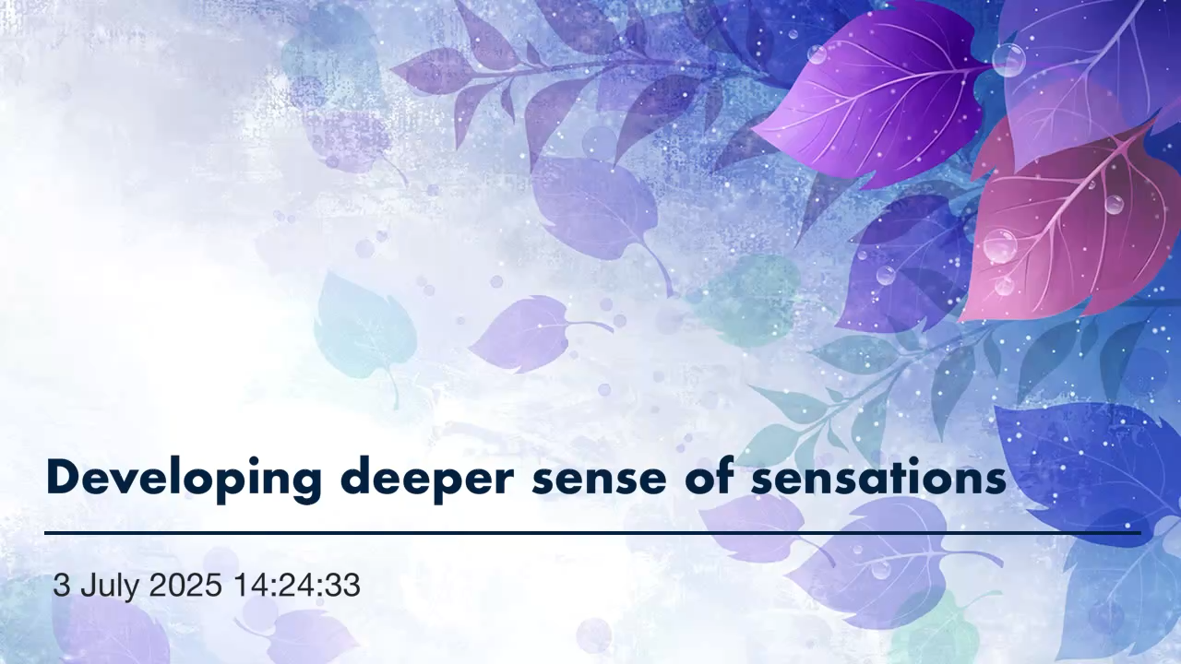

**C.2.3. Experiencing /exploring feelings**

So, the above exercise underpins our initial exploration of sensations.

However, this time, we start to notice when we have wrapped awareness around the sensations if they are pleasant, unpleasant or neutral. There is no sense of trying to change things, just being with that sensation, with a friendly attention.

We can so often get swept away by our feelings. By developing a spacious attitude and awareness, we will still experience them but not allow them to take away our freedom.

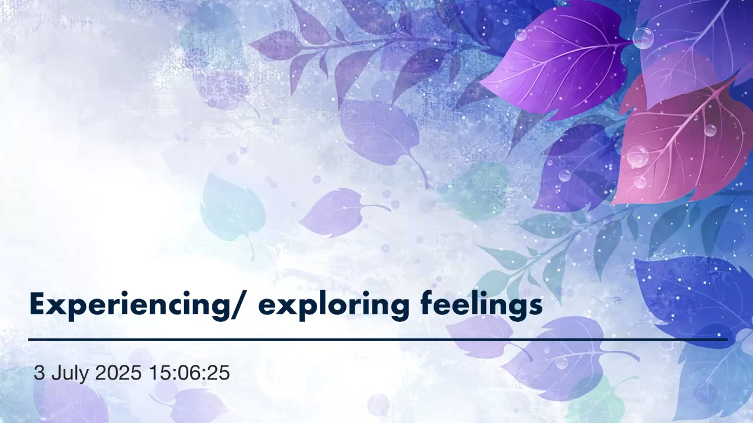

**C.2.4. Acknowledging and exploring moods and emotions.**

Exploring our mood/emotion is not a question of going over an incident at work or home in our head for our perceived narrative behind the mood. We can use our catalogue of previous experience from the meditations above to uncover our mood.

Sometimes this may appear simple to join up the dots and other times really challenging. For this meditation we may need to add into the mix the attitude of patience!

The breath I usually find is a great weathervane for our mood.

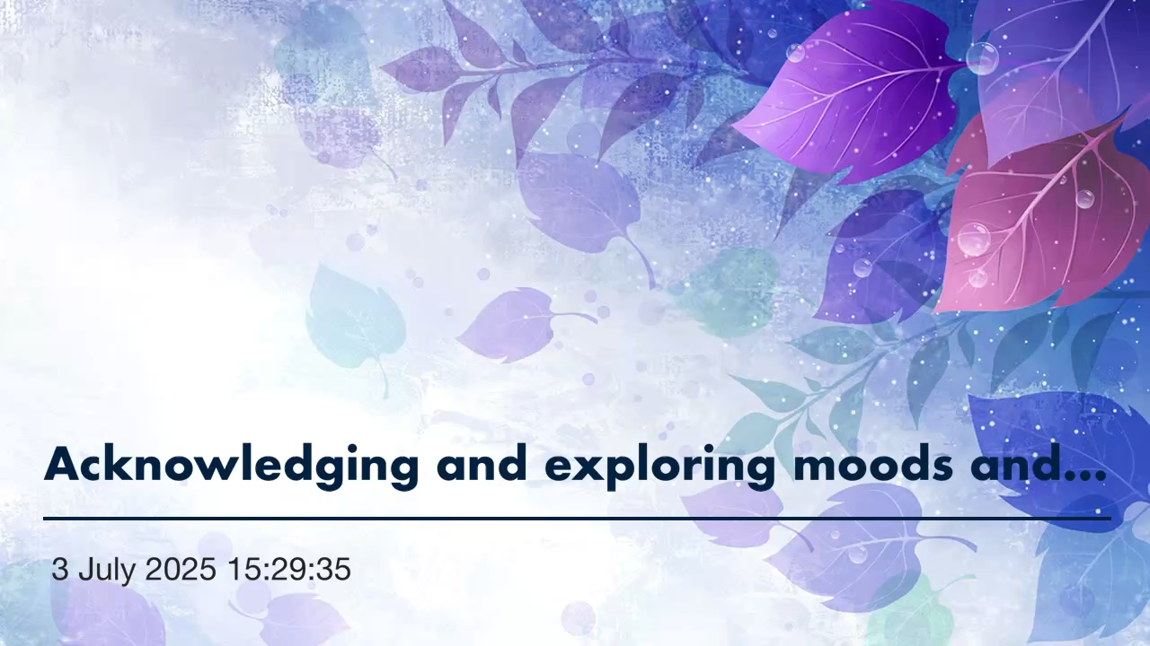

**C.2.5. Response to people.**

We will all have experienced meeting someone and just feeling a little guarded, or instantly getting on well with them, or another time meeting someone and feel quite indifferent.

When I worked as the clinical lead in an NHS chronic pain Department and saw 16 patients a day who were not in a good place physically or mentally. I ended up myself with chronic pain. I was woefully unaware at the time, but on reflection it became very clear how my physiology changed in relationship to being constantly surrounded by suffering. However, if I had learnt to respond in a different way things would have been different.

Some people and their way of being in the world can close us off, make us constrict, others open and enable us to grow. It’s the same with places and spaces we inhabit, or situations that arise in our lives.

When we experience a nightmare we awake sweating, muscles tight, heart pounding. What happens in our mind changes our body. Or if we look at it another way, what is happening in our body gives rise to what is happening in our mind. A two-way street?

This meditation recalls different people. one we like, one we dont and one we feel indifferent about. We will need to be aware of a physical and emotional response in terms of feeling different sensations rise and fall.

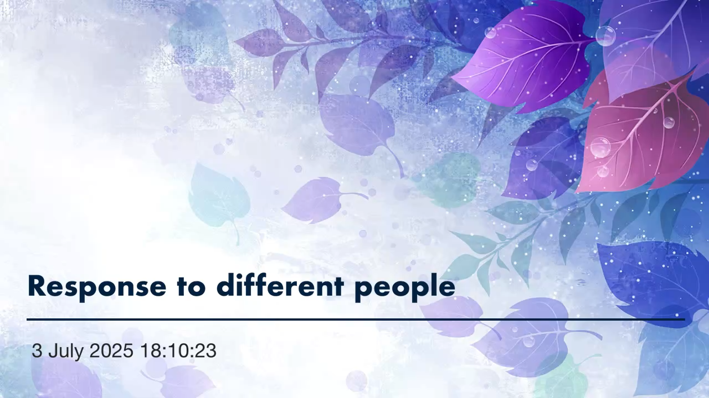

**Conclusion**

By developing our ability to feel we can become more familiar with certain moods and emotions. Ultimately through this process we may begin to see choice in how we respond to challenges in our lives rather than simply experiencing our usual habitual reaction. All it requires is persistence, repetition and a smile. The next stage is the loving kindness meditation. Email me if you wish to continue the journey, and I will send on to you the next text and batch of recordings. [stuart.yoga@gmail.com](mailto:stuart.yoga@gmail.com)